### **LLAMA - 7B**

In order to install and run the pretrained LLAMA model with 7 billion parameters the following steps are to be reproduced:

1. Go to <https://huggingface.co/codellama/CodeLlama-7b-hf>
2. Click on the files and versions section
3. For each commit, download each of the files individually clicking on the download button.
4. Save all the files in a folder - codellama
5. Check carefully if all the files are downloaded and the size of the files matches the commits(if there are 7 files all of them has to be downloaded and if a file is 7GB in the commit it should be the same size after you downloaded it)
6. Next, go to the notebook and import the libraries ( code added in the notebook)
7. Save the pretrained tokenizer ( code added in the notebook)
8. Load the model and tokenizer ( code added in the notebook)
9. Create a pipeline for the model ( code added in the notebook)
10. Finally test the model with a prompt to check if the model is working successfully ( code added in the notebook)

Notebook: [Link](https://drive.google.com/file/d/1xLT08CnNT5XLPiUizTID8tVpeCypltUx/view?usp=sharing)

Transformer library should be atleast 4.33

### **Vicuna - 13B lmsys:**

Vicuna is an auto-regressive language model based on the transformer architecture. Vicuna-13B is an open-source chatbot trained by fine-tuning LLaMA on user-shared conversations collected from ShareGPT. We need to recreate the following steps to use vicuna in our local computer

1. Go to <https://huggingface.co/lmsys/vicuna-13b-v1.3>
2. Click on the files and versions section
3. For each commit, download each of the files individually clicking on the download button.
4. Save all the files in a folder - lmsys_vicuna-13b-v1.3
5. Check carefully if all the files are downloaded and the size of the files matches the commits(if there are 7 files all of them has to be downloaded and if a file is 7GB in the commit it should be the same size after you downloaded it)
6. Next, go to the notebook and import the libraries ( code added in the notebook)
7. Load the model and tokenizer ( code added in the notebook)
8. Save the pretrained tokenizer ( code added in the notebook)
9. Create a pipeline for the model ( code added in the notebook)
10. Finally test the model with a prompt to check if the model is working successfully ( code added in the notebook)

Notebook: [Link](https://drive.google.com/file/d/1osCKVFKzgN4RU5JX7Fv2LKf-rXD-OEVc/view?usp=sharing)

### **Vicuna - 13B TheBloke:**

Vicuna-13B is an open-source chatbot trained by fine-tuning LLaMA on user-shared conversations collected from ShareGPT. Preliminary evaluation using GPT-4 as a judge shows Vicuna-13B achieves more than 90% quality of OpenAI ChatGPT and Google BARD while outperforming other models like LLaMA and Stanford Alpaca in more than 90%.

1. Go to <https://huggingface.co/TheBloke/stable-vicuna-13B-HF>
2. Click on the files and versions section
3. For each commit, download each of the files individually clicking on the download button.
4. Save all the files in a folder - bloke_stable_vicuna
5. Check carefully if all the files are downloaded and the size of the files matches the commits(if there are 7 files all of them has to be downloaded and if a file is 7GB in the commit it should be the same size after you downloaded it)
6. Next, go to the notebook and import the libraries ( code added in the notebook)
7. Load the model and tokenizer ( code added in the notebook)
8. Save the pretrained tokenizer ( code added in the notebook)
9. Create a pipeline for the model ( code added in the notebook)
10. Finally test the model with a prompt to check if the model is working successfully ( code added in the notebook)

Notebook: [Link](https://drive.google.com/file/d/1hFZNzoYXO1yZ2Yh63SFBdbYpweQF0uBy/view?usp=sharing)

### **Mistral-7B:-**

Mistral 7B is a 7.3B parameter **uncensored** model that:

* Outperforms **Llama 2 13B** on all benchmarks
* Outperforms **Llama 1 34B** on many benchmarks
* Approaches CodeLlama 7B performance on code, while remaining good at English tasks
* Uses Grouped-query attention (GQA) for faster inference
* Uses Sliding Window Attention (SWA) to handle longer sequences at smaller cost

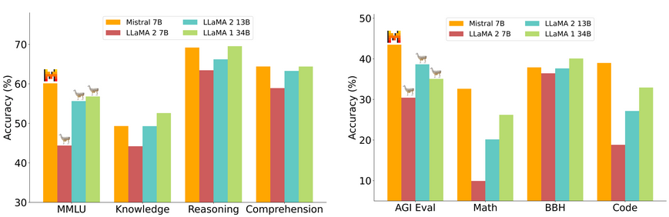

Mistral AI includes Timothee Lacroix, Guillaume Lample, and Marie-Anne Lachaux, all authors on the original Llama paper who left Meta and the latter two being the co founders.

Follow the following steps to execute :

1. Go to <https://huggingface.co/mistralai/Mistral-7B-v0.1>
2. Click on the files and versions section
3. For each commit, download each of the files individually clicking on the download button.
4. Save all the files in a folder - mistral_7b
5. Check carefully if all the files are downloaded and the size of the files matches the commits(if there are 7 files all of them has to be downloaded and if a file is 7GB in the commit it should be the same size after you downloaded it)
6. Next, go to the notebook and import the libraries ( code added in the notebook)
7. Load the model and tokenizer ( code added in the notebook)
8. Create a pipeline for the model ( code added in the notebook)
9. Finally test the model with a prompt to check if the model is working successfully ( code added in the notebook)

**Troubleshooting**

If you see the following error:

* KeyError: 'mistral'

Or:

* NotImplementedError: Cannot copy out of meta tensor; no data!

Ensure you are utilizing a stable version of Transformers, 4.34.0 or newer.

Notebook: [Link](https://drive.google.com/file/d/1sC-pwPH8UCEyRVzt16BGbzzKwwyk5mm9/view?usp=sharing)

### **ollama**

**What is ollama ?**

Ollama is a tool designed to help users quickly and effortlessly set up and utilize large language models on their local machines.

[Github Repo](https://github.com/jmorganca/ollama)

**Setup ollama**At first you need to install ollama using the following command:

curl https://ollama.ai/install.sh | sh

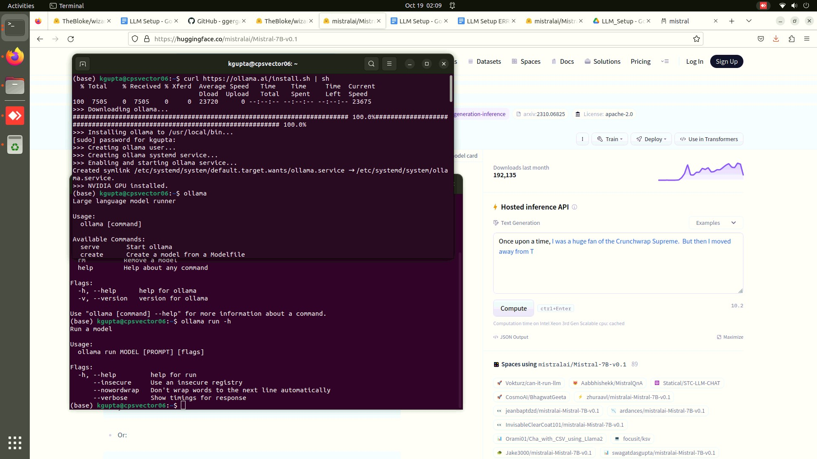

ollama → Shows the commands that you can you use

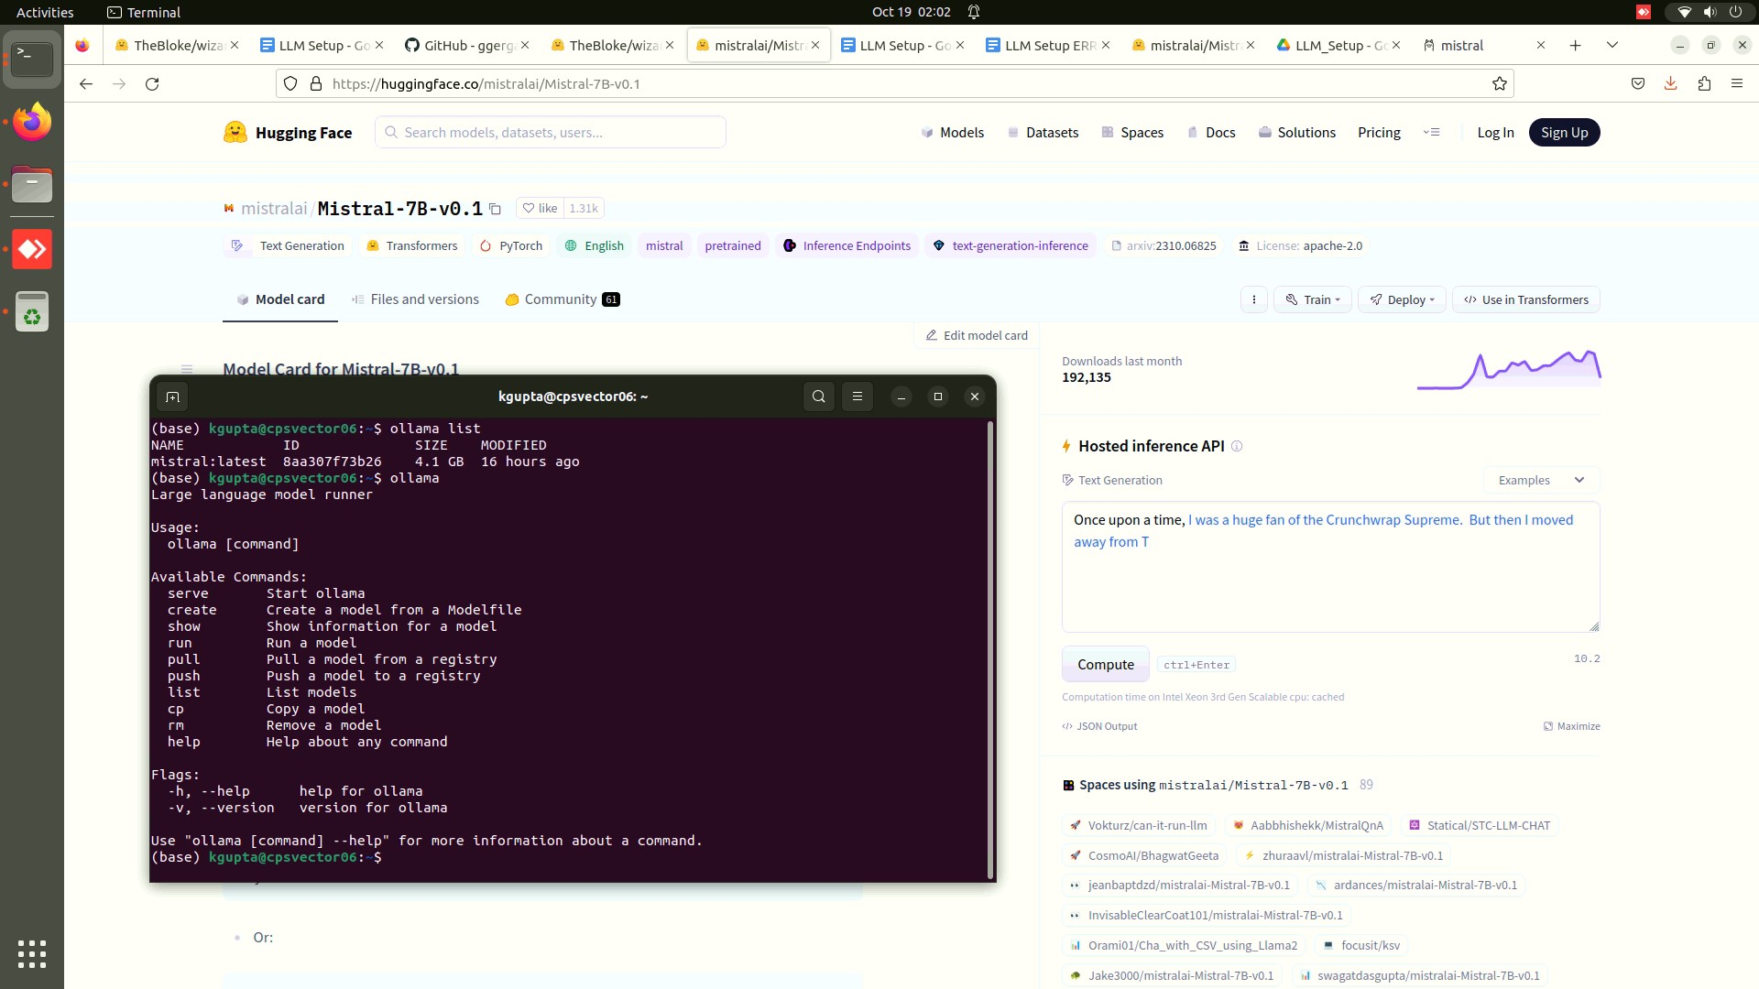

ollama run -h → Shows you the commands that you can run

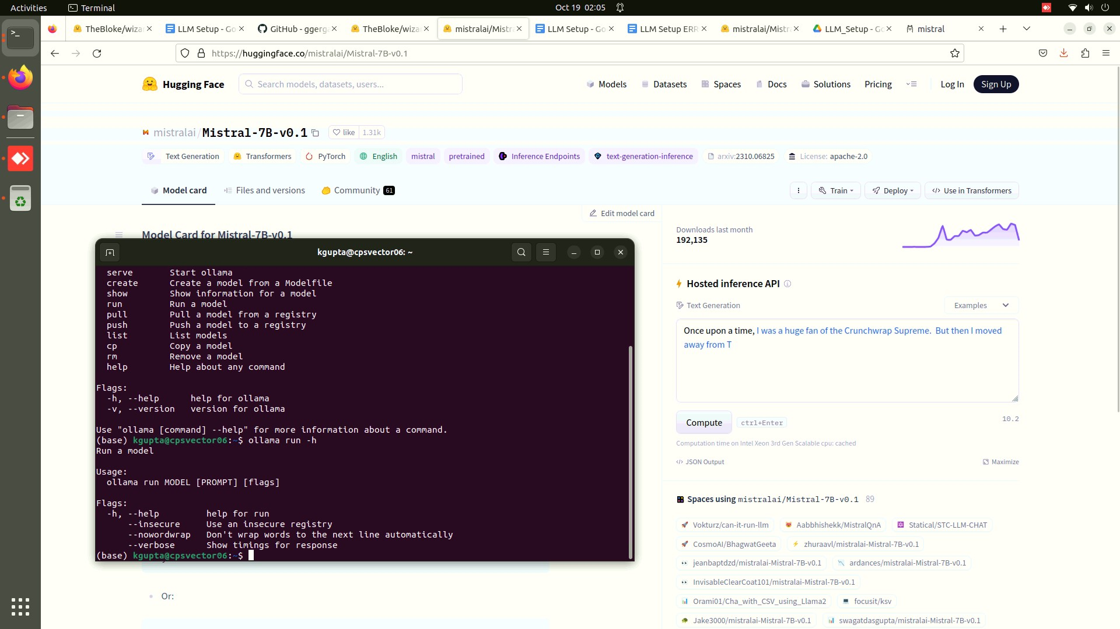

ollama list → Shows you if you have any models

**Run Model**

ollama run mistral → We will now run the model [mistral](https://ollama.ai/library/mistral), if it is not previously installed it will install the model on your local PC

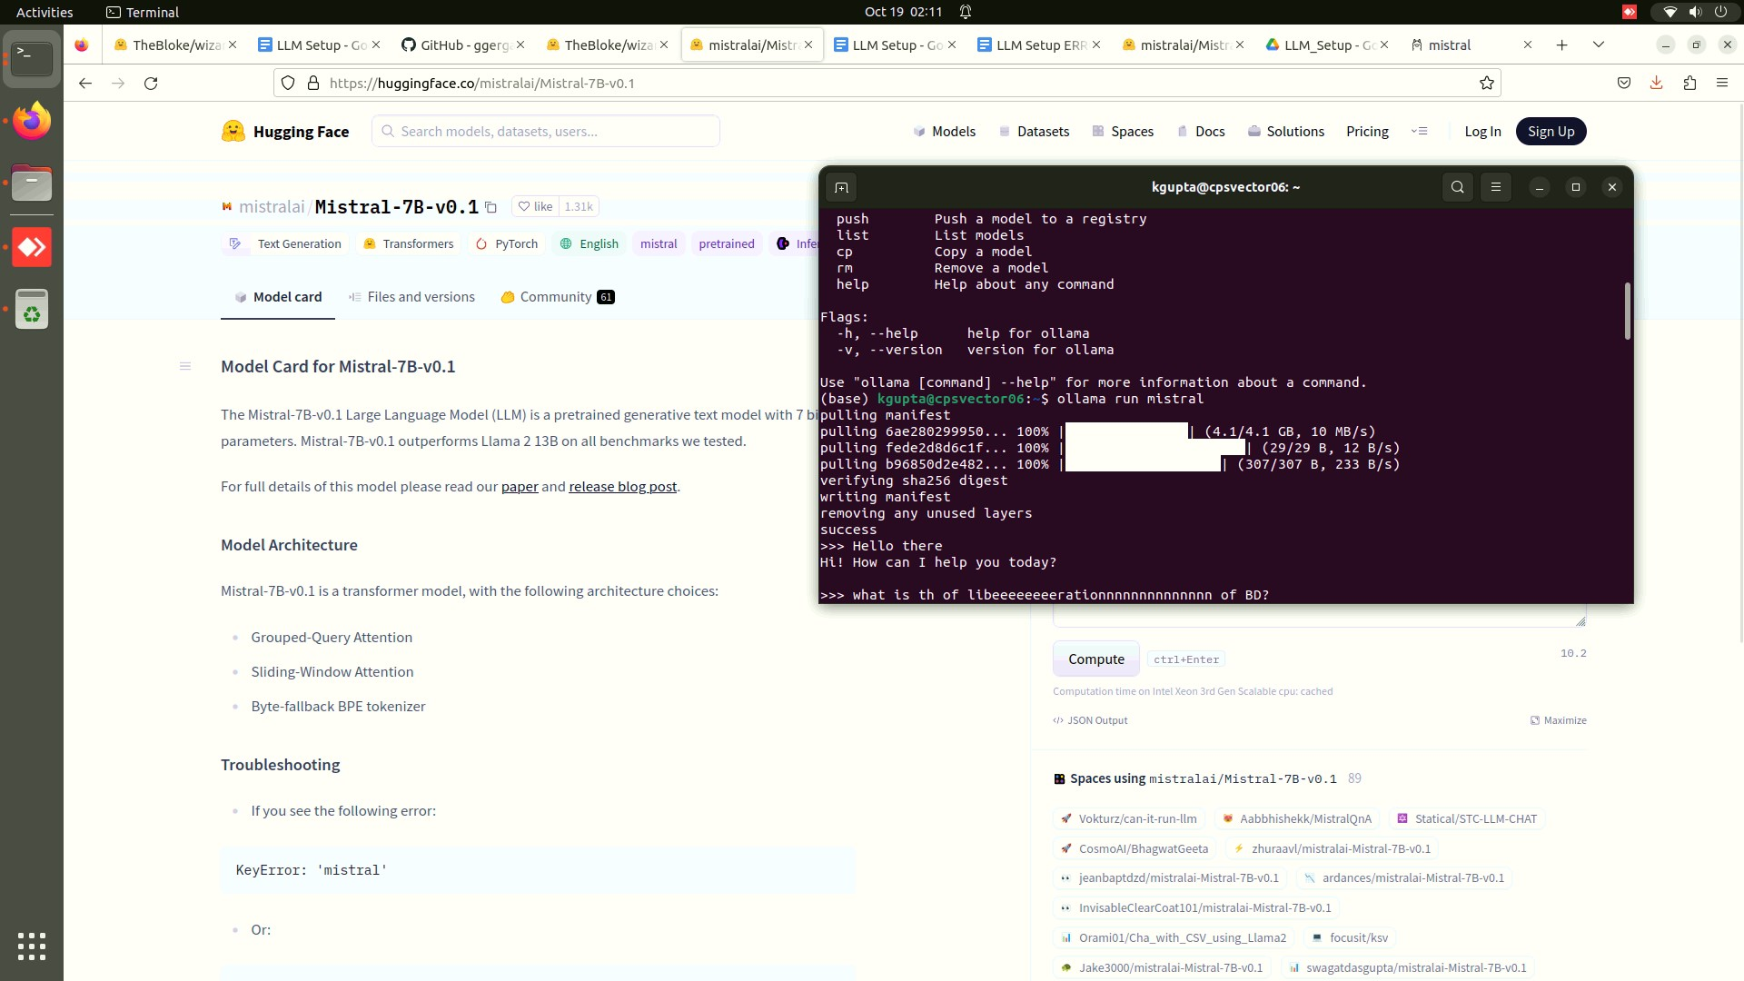

After running the mode you can use :

/? → shows what commands you can run in chat mode

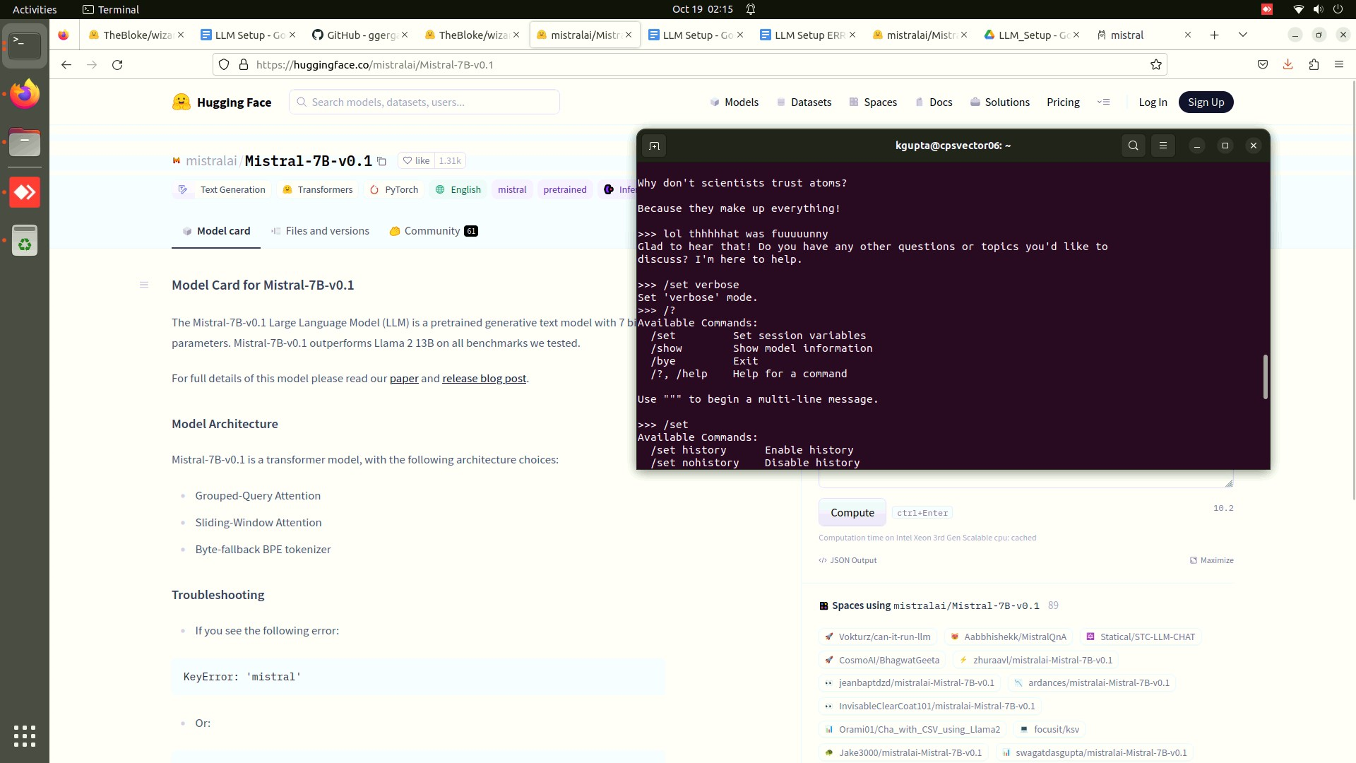

You can explore the commands, here we are looking into the /set command

/set command

verbose - > what speed we are getting shows no of tokens per second

pip install git+https://github.com/hwchase17/langchain.git

**Preparing Custom prompt:**

nano /tmp/mistralPrompt → model file

From mistral

PARAMETER temperature 0.7

System """

You are a funny software engineer, answer with proper knowledge

"""

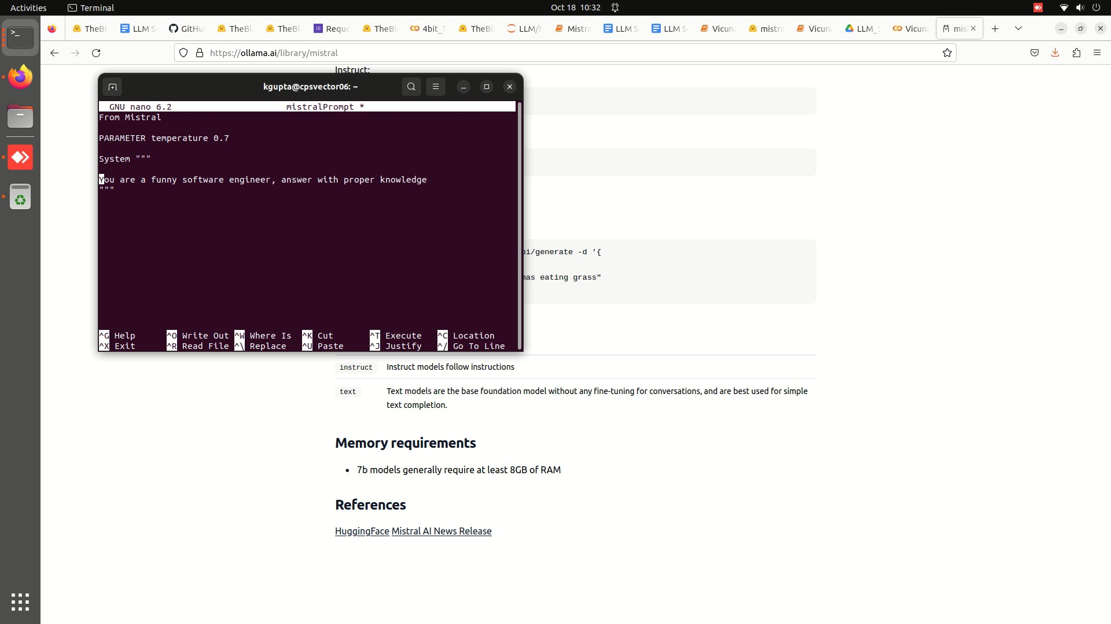

ollama create prompt1 -f /tmp/mistralPrompt → create the prompt using the model file

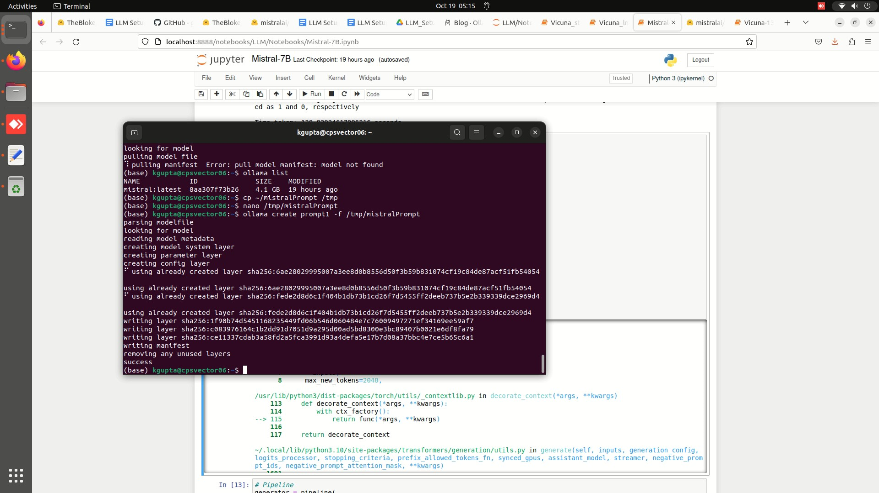

ollama run prompt1 → Run the prompt you just created

/exit → exit chat

ollama rm prompt1 → If you want to remove the prompt from the list

**Important Links:**

1. <https://github.com/jmorganca/ollama/blob/main/README.md>
2. <https://python.langchain.com/docs/integrations/llms/ollama>

#### **Mistral with ollama:**

After you have successfully setup the ollama you can use the model with langchain to build applications.

Notebook Link : [Link](https://drive.google.com/file/d/1OpGnJaeNa5ea00O9E93yKCaWIEPZ4G-Y/view?usp=sharing)